Caching

Definition
# Source: AI Source: Provided by: [Data Path: Persons Table -> ID Column: 1, Name_En Column: Motasem Essam] -> From: [Chatgpt (GPT‑5 Mini)] on [2/12/2026]
Caching is a web design technique where frequently used data (like web pages, images, or files) is stored temporarily so that it can be loaded faster the next time it is needed.

Simple Definition
# Source: AI Source: Provided by: [Data Path: Persons Table -> ID Column: 1, Name_En Column: Motasem Essam] -> From: [Chatgpt (GPT‑5 Mini)] on [2/12/2026]
Caching = saving data so it can be reused quickly without downloading it again.

How Caching Works
# Source: AI Source: Provided by: [Data Path: Persons Table -> ID Column: 1, Name_En Column: Motasem Essam] -> From: [Chatgpt (GPT‑5 Mini)] on [2/12/2026]
• When a user visits a website, data is stored in the browser or server
• On the next visit, the website loads data from the cache instead of downloading it again
• This reduces loading time and server requests
• Can be implemented using browser cache, server cache, or CDN cache

Purpose of Caching
# Source: AI Source: Provided by: [Data Path: Persons Table -> ID Column: 1, Name_En Column: Motasem Essam] -> From: [Chatgpt (GPT‑5 Mini)] on [2/12/2026]
• Improve website loading speed
• Reduce server load
• Save bandwidth
• Enhance user experience
• Make websites more efficient

Advantages
# Source: AI Source: Provided by: [Data Path: Persons Table -> ID Column: 1, Name_En Column: Motasem Essam] -> From: [Chatgpt (GPT‑5 Mini)] on [2/12/2026]
• Faster page loading for returning users
• Reduces server requests and traffic
• Saves bandwidth and resources
• Improves performance
• Works well with large websites

Disadvantages
# Source: AI Source: Provided by: [Data Path: Persons Table -> ID Column: 1, Name_En Column: Motasem Essam] -> From: [Chatgpt (GPT‑5 Mini)] on [2/12/2026]
• Users may see outdated content if cache is not updated
• Requires proper configuration to work correctly
• Can cause inconsistencies if data changes frequently
• Debugging cache issues can be difficult
• Takes up storage space in browser or server

Examples
# Source: AI Source: Provided by: [Data Path: Persons Table -> ID Column: 1, Name_En Column: Motasem Essam] -> From: [Chatgpt (GPT‑5 Mini)] on [2/12/2026]
• Images or files stored in the browser for faster loading
• Frequently visited web pages loading quickly on repeat visits
• Using a Content Delivery Network (CDN) to cache content globally
• Browser storing website data like icons and stylesheets

Difference Between Caching and Other Techniques
# Source: AI Source: Provided by: [Data Path: Persons Table -> ID Column: 1, Name_En Column: Motasem Essam] -> From: [Chatgpt (GPT‑5 Mini)] on [2/12/2026]
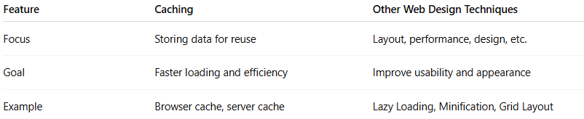
Feature | Caching | Other Web Design Techniques
Focus | Storing data for reuse | Layout, performance, design, etc.
Goal | Faster loading and efficiency | Improve usability and appearance
Example | Browser cache, server cache | Lazy Loading, Minification, Grid Layout

